Project Overview_________
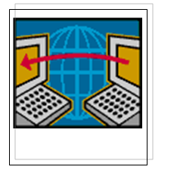

Objective
The output of the project should be an encased module accompanied with its software to facilitate the control and monitoring of an industry using a PC, laptop or PDA via a wired and/or wireless network. It is in effect, an implementation of a SCADA (System Control And Data Acquisition) system using a wireless network.

Abstract
In an industrial process plant it is common that all local controllers be connected to a central control room where the control engineer has the equipment that enables him to monitor and control the whole process. Common tasks inside the control room are monitoring variables, changing set points, tuning local controllers, and production scheduling. Local controllers usually are microcontrollers with analog interface to the local sensors and actuators, and digital interface to some type of local network to connect to other controllers and to the central control room.
As the control engineer walks around the process plant he needs to have some of the capabilities of process monitoring and control he usually has in the control room. The objective of this project is to develop and implement a wireless local network that connects all local controllers to the control engineer laptop or PDA (Personal Digital Assistant) to allow him to perform tasks that require him to be in the control room. The wireless network is not intended to replace any existing local network, whether a field bus or an Ethernet, but it will work in parallel to any existing network providing the control engineer with a portable control room.

Minimum Implementation Tasks Required
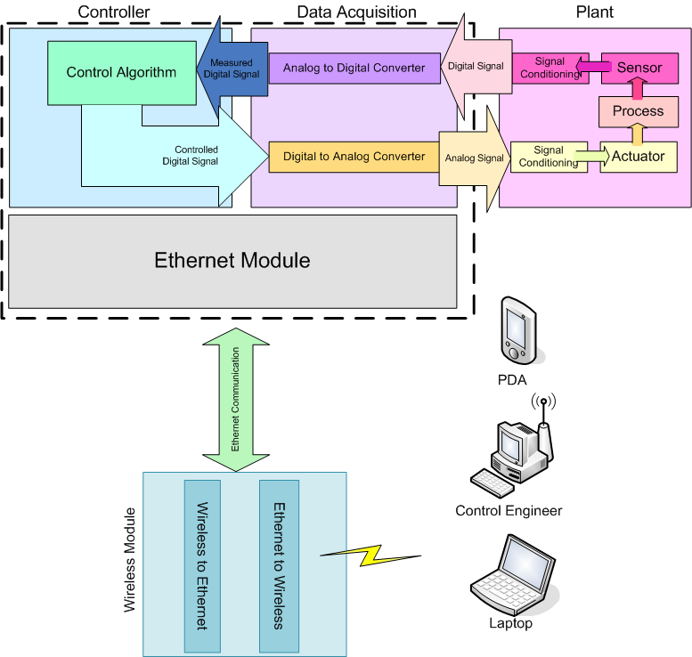
Figure 1 Overall design of the project.
- Data Acquisition: Convert analog signals in their standard voltage and current ranges from the sensors into digital forms, and convert digital signals from the microcontroller to the actuators into analog signals within their standard ranges. It is required to implement such a data acquisition card with 8 input and output channels.
- Control: Implement a few local control loops (PID and On/Off control) using suitable microcontrollers. The processes to be controlled may be RC electrical circuits which are analogous to hydraulic, thermal and mechanical processes. The controller should be able to implement up to 8 control loops.
- Hardware: Add wireless networking capabilities to each local microcontroller via one of its standard interfaces. This networking capability should allow the microcontroller to receive the digital controller parameters (e.g. set point, PID values, On/Off conditions) from the laptop, PDA or PC as well as transmitting output values to the control room.
- Software: Develop the software that integrates the local controllers and the engineer's portable station to allow the engineer to control and monitor the processes. The software should have different GUI capabilities to display the output values (graphs, graphics simulation of the real process, LCD screen, etc.).

Extra Implementation Tasks
- Data Acquisition: Allow the control engineer to choose any voltage or current ranges for each input or output channel. That is, the ranges of the I/O channels to be programmable.
- Interface with PLC: Software to be capable of interfacing with any PLC model given its driver.
- Control: Implement, along with PID loops and On/Off, RST controller, fuzzy controller and PLC ladder diagram. That is, the control engineer draws on the software a PLC ladder diagram to be implemented by the microcontroller at the plant.
- VPN: Form a secure VPN (Virtual Private Network) so that the control engineer may monitor the process from any part in the world.
- Camera: The software to support receiving pictures or videos of the process via the wireless network.
- Speaker: Allow the engineer to provide orders remotely to the workers at the plant to be heard through a speaker at the process.

How Documentation is Organized
The documentation is divided into 6 parts:
- Part 1 describes the Local Controller module; the part of the project which implements the data acquisition and control algorithms.
- Part 2 describes the Ethernet Controller module; the part of the project which provides the Ethernet interface to make the controller a node in a network able to be communicated with.
- Part 3 describes Wireless Accessibility; how the different nodes (whether they are user stations or local controllers) may be accessible remotely without wires.
- Part 4 describes the software on the laptop or PC to allow a control engineer to design, control and monitor a process.
- Part 5 describes how the software is modified to be implemented on a PDA or PocketPC.
- Part 6 describes some case studies of real-life applications or experiments performed in our project.

